

|  |
| --- |
| DATA VISUALIZATION USING TABLEAU |
| ASSIGNMENT 4 |
| **October 23, 2022.**  INDIANA UNIVERSITY (BLOOMINGTON)  Authored by: VARSHA R IU ID: 2000751388 Sem: Fall 2022 |



# Introduction

|  |  |  |  |  |  |  |  |  |  |  |  |  |  |  |  |  |  |  |  |  |  |  |  |  |  |  |  |  |  |  |  |  |  |  |  |  |
| --- | --- | --- | --- | --- | --- | --- | --- | --- | --- | --- | --- | --- | --- | --- | --- | --- | --- | --- | --- | --- | --- | --- | --- | --- | --- | --- | --- | --- | --- | --- | --- | --- | --- | --- | --- | --- |
| Data visualization is achieved using Tableau, a software package focusing on business intelligence (BI). The word tableau refers to a graphic representation or description. As a novice with Tableau, I have experimented with the software and built a few visualizations. I have tried to implement some of my learnings from this tableau course The purpose of this report is to discuss these visualizations. For each graph, the following information will be discussed:   * Plots built using the dataset. * Plot analysis.   + - Discover underperforming demographical segments.     - Analyze the past and present business trends. * Potential growth ideas and strategies.  Dataset For the visualizations, we will use the following given dataset that contains a year’s worth of a company’s website usage data.  Name: Analytics visualization challenge dataset.     |  |  | | --- | --- | | **Data column definitions** |  | | day | The calendar day | | site | Company site visited by users | | new_customer | 0 = returning customer; 1 = new customer; null = neither | | platform | The type of device used by a website visitor | | visits | The number of distinct website visits; 1 session may have multiple visits | | distinct_sessions | The number of distinct website visitors; 1 session may have multiple visits | | orders | The number of website orders | | gross_sales | The total gross sales for website orders | | bounces | The number of visits that only viewed one page | | add_to_cart | The number of visits that added a product to cart | | product_page_views | The number of product pages viewed | | search_page_views | The number of search pages viewed | |  |  | | **Calculated fields** |  | | conversion_rate | ='orders'/'visits' | | bounce_rate | ='bounces'/'visits' | | add_to_cart_rate | ='add_to_cart'/visits' |  VisualizationsSheets:  * **Plot built using this dataset**      * **Plot analysis**   Attributes used for this plot: Day, visits, gross sales  Columns: DAY(Day)  Rows: AVG(visits), AVG(gross sales)  Marks: Labels – SUM(Orders)  Here we are trying to compare and see the business trend over the whole year.   * **Underperforming segments, potential growth ideas and strategies** * Since the number of sales and website visit is highest during the month of December, the company should focus on making the most profit at the end of each year by attracting customers with discounts, vouchers, advertisements, etc. * The company should focus on coming up with new products that can be useful to customers during February – July. * **Plot built using this dataset**   Original plot: Zoomed in plot:     * **Plot analysis**   Attributes used for this plot: Day, conversion rate, ross sales, bottom n conversion rates (parameter)  Columns: AVG(conversion_rate)  Rows: DAY(Day), bottom n conversion rates (parameter)  Marks: Color – SUM(gross sales)  Filter: DAY(Day)  Here we are trying to compare and see the orders per visit over the year week wise.   * **Underperforming segments, potential growth ideas and strategies** * Using the parameter slide, we can see that the 2nd week of February has the lowest conversion rate. * Jan, Feb, Jun, Aug and Nov are the months that contains the lowest orders per visit rate and therefore the company should focus on attracting more customers during these months by increasing and bettering their sales strategies. * **Plot built using this dataset**      * **Plot analysis**   Attributes used for this plot: Platform, add to cart rate, top nearning days (set)  Columns: Platform  Rows: AVG(add to cart rate)  Marks: Color – top nearning days (set)  Here we are trying to compare the platforms used to add customer’s products to the cart.   * **Underperforming segments, potential growth ideas and strategies** * The platform that needs the lowest attention to attract customers should be SymbianOS because the add to cart rate is literally 0. Blackberry follows the list. Therefore, adapting the company’s webisite to these platforms should be the least priority tasks. * As expected, iOS and android are ranking the charts here and the company should work on channeling their website to fit these platforms more. * **Plot built using this dataset**      * **Plot analysis**   Attributes used for this plot: Platform, orders, gross sales, visits, top n platforms (set)  Columns: SUM(gross sales)  Rows: top n platforms (set), Platform  Marks: Color – SUM(orders), Details – SUM(visits)  Here we are trying to compare the platforms that has the most sales and orders.   * **Underperforming segments, potential growth ideas and strategies** * SymbianOS has zero orders or sales so that could an OS that can be removed from their platform. * Highest number of sales is from the windows platform. iOS and Macintosh are 3rd and 4th place and therefore adapting to these platforms cannot be ignored. * The company should invest more in building the website most suited to a windows and MacOSX so that maximum numbers of customers are pleased. * **Plot built using this dataset**      * **Plot analysis**   Attributes used for this plot: Platform, orders, site, new customer  Columns: Site  Rows: MIN(new customer)  Marks: Color – Platform, angle – SUM(orders), Label – MAX(Platform)  Here we are trying to compare which platform is used the most to browse the different sites.   * **Underperforming segments, potential growth ideas and strategies** * Since Botly site is visited by only android users. Therefore, the website should be designed to fit the android devices for the most part. * Widgetry site should be build taking apple devices into consideration as most of its users are apple device users. * Acme site is the site that has the highest platform diversity. Acme might be the most challenging site to maintain considering variety of users access it. * **Plot built using this dataset**      * **Plot analysis**   Attributes used for this plot: Orders, site, new customer, distinct session, product page views  Columns: Site, CNT(New customers)  Rows: SUM(distinct session), SUM(product page views), AVG(Orders)  Marks: Color – Measure names  Here we are trying to analyze new customer and their usage data   * **Underperforming segments, potential growth ideas and strategies** * Acme seems to prove itself as the most used site. It attracts the most number of new customers. To maintain/better the growth, the site needs to be maintained very well so that the new customers do not face any site related issues at the very start of their experience. * Pinnacle and Sortly are the lowest performing sites in these criteria. The company has to focus on bettering these sites and attracting more users to better its engagement which inturn will bring profit to the company. |

# Dashboards:

Dashboards are a combinations on one or more worksheets. Multiple worksheets can be merged into a single dashboards. Tableau worksheets are the primary building blocks for the dashboard. In this assignment, there are 3 dashboards created after grouping a couple of sheets for each dashboard based on their similarity of focus attribute.

**1)**

* **Dashboard**

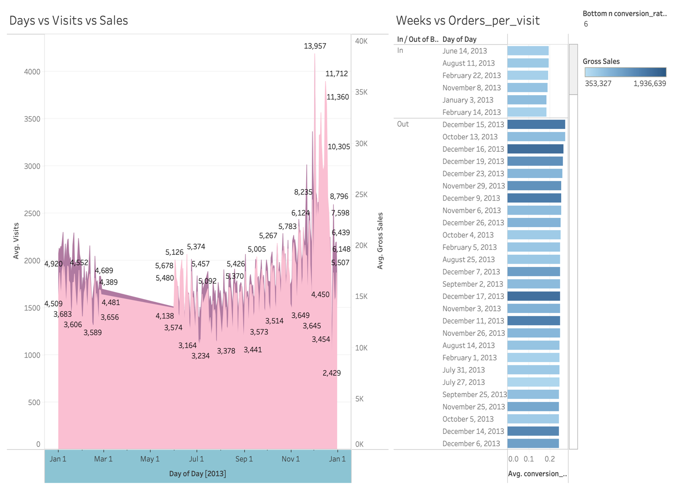

* **Analysis**

Grouping attribute: Day

You can notice that the first two visualizations are based upon analyzing the time trend over the year to confirm which time period has the least and most number of sales. By putting together these two visualizations, we can study the sales period trend that can help company work on their strategies better for different times of the year.

**2)**

* **Dashboard**

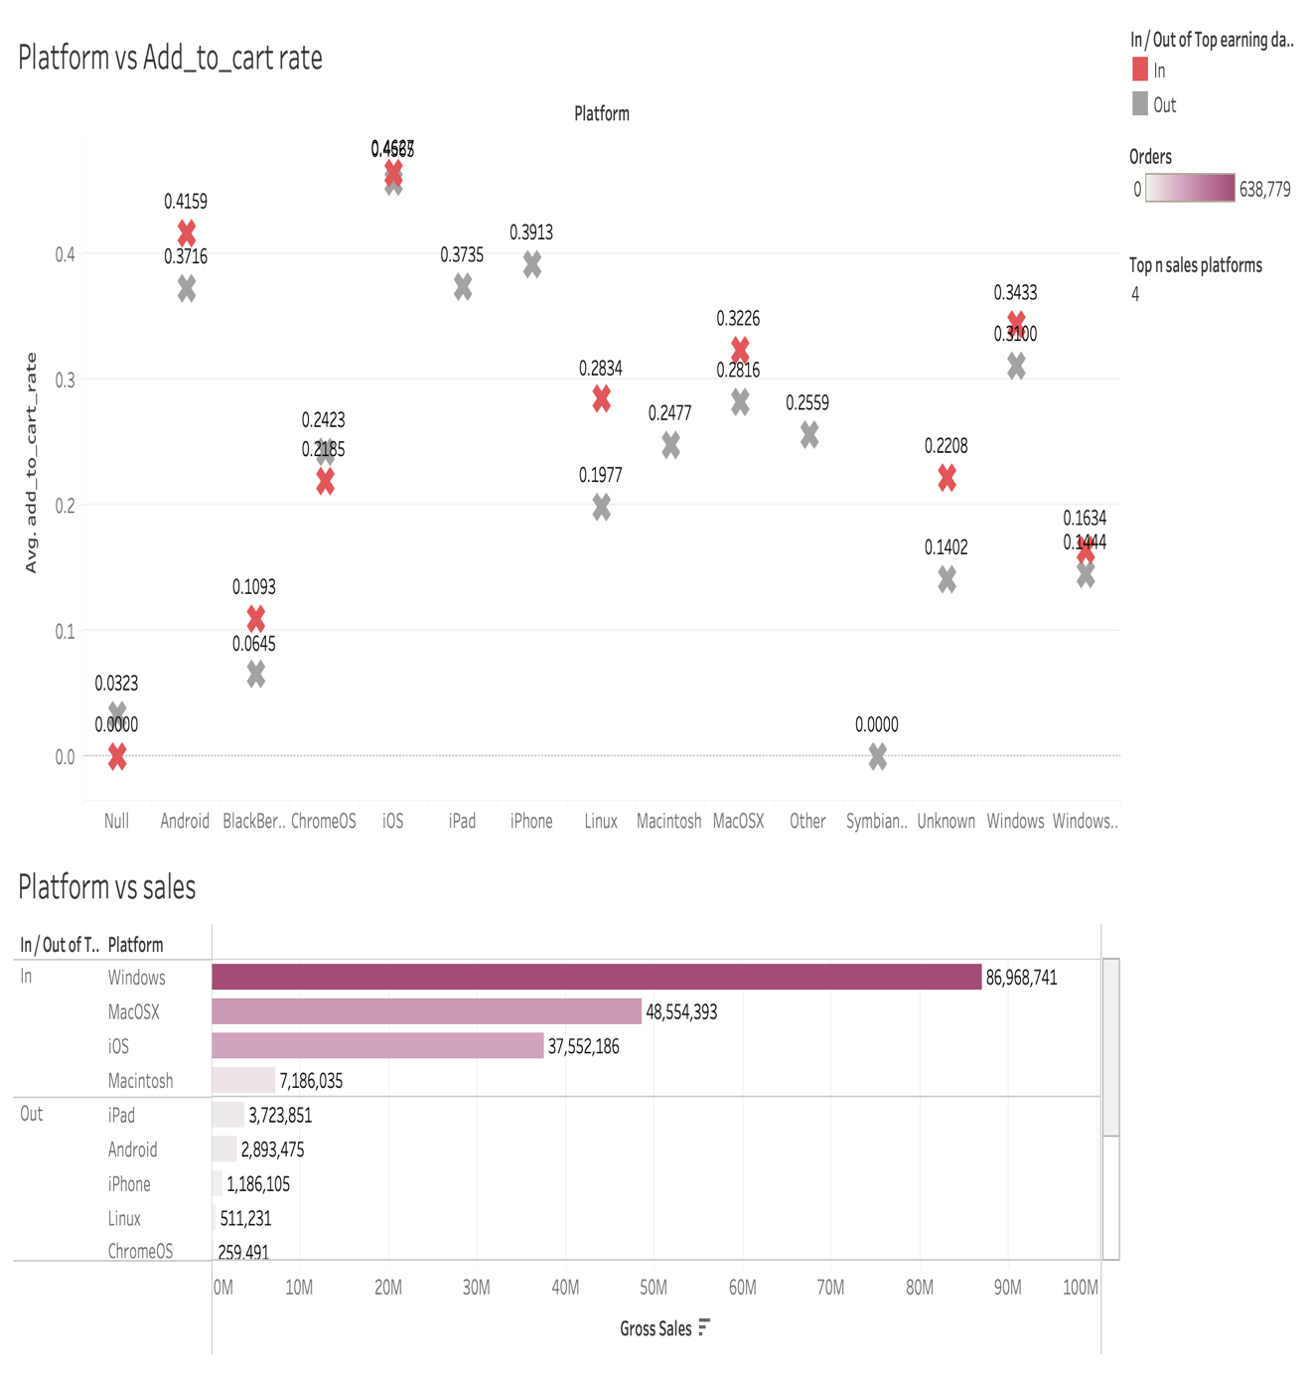

* **Analysis**

Grouping attribute: Platform

Here the platform based analysis sheets have been grouped together to study the sales and order trends over different platforms that the company’s sites offer its services. By grouping these two visualizations together, we can analyze the platform vs add to cart vs sales, i.e., most number of users add the products into the cart which they most probably buy across different platforms.

**3)**

* **Dashboard**

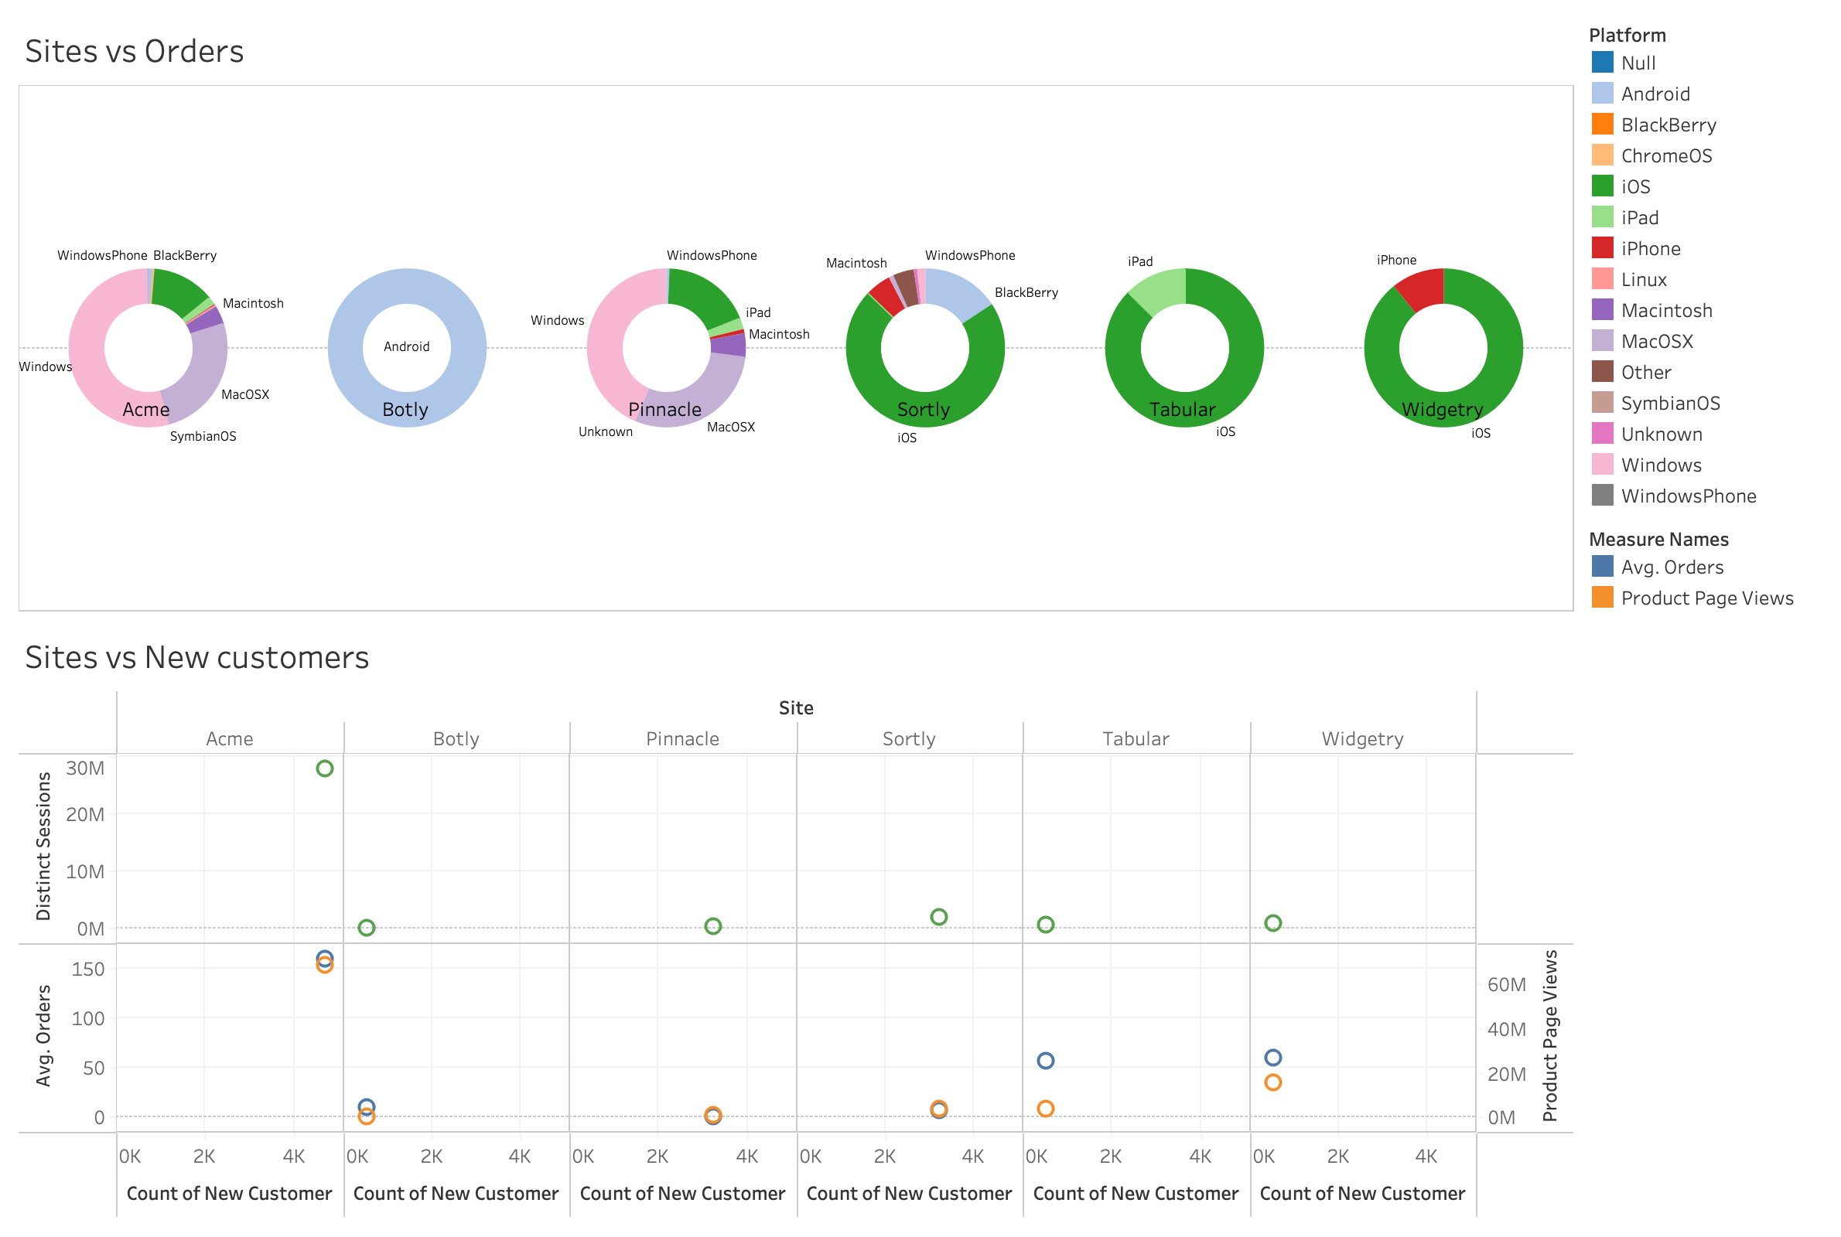

* **Analysis**

Grouping attribute: Sites

Grouping up the visualizations that concentrate on analyzing site related data helps us derive import insights on which site is the most popular and needs most maintenance and which site is least used that can be taken down or make improvements based on its lacking features. This also gives us information about which site attracts the most customers so that website can be used as a reference for other low performing websites.

# Storyboard:

In Tableau, a story is a sequence of visualization that work together to convey information. Either sheets or dashboards can be put together in the storyboard to present the information in the most efficient and convenient way. In my assignment, the best way to build the storyboard was to put all the dashboards together in 3 story points: days, platforms, and sites. Here is a summary of the storyboard put together as images.

